**Name:** Anshul Shirbhate

**Roll No:** D – 5

**Practical No:** 7

**Practical Aim:** Configure network using distance vector routing protocol in cisco packet tracer.

**Commands:**

**For Router0:**

Router&gt;en

Router#config t

Enter configuration commands, one per line. End with CNTL/Z.

Router(config)#interface fastEthernet 0/1

Router(config-if)#ip address 10.0.0.2 255.0.0.0

Router(config-if)#bandwidth 64

Router(config-if)#no shutdown

Router(config-if)#

%LINK-5-CHANGED: Interface FastEthernet0/1, changed state to up

%LINEPROTO-5-UPDOWN: Line protocol on Interface FastEthernet0/1, changed state to

up

%IP-4-DUPADDR: Duplicate address 10.0.0.2 on FastEthernet0/1, sourced by

0001.6475.411D

Router(config)#interface serial 0/0/0

Router(config-if)#ip address 192.168.1.249 255.255.255.252

Router(config-if)#clock 6400

Router(config-if)#clock rate 64000

Router(config-if)#bandwidth 64

Router(config-if)#no shutdown

%LINK-5-CHANGED: Interface Serial0/0/0, changed state to down

Router(config-if)#exit

Router(config)#interface serial 0/0/1

Router(config-if)#ip address 192.168.1.254 255.255.255.252

Router(config-if)#clock rate 64000

Router(config-if)#bandwidth 64

Router(config-if)#no shutdown

%LINK-5-CHANGED: Interface Serial0/0/1, changed state to down

Router(config-if)#exit

Router(config-if)#exit

Router(config)#

Router(config)#router rip

Router(config-router)#network 10.0.0.0

Router(config-router)#network 192.168.1.253

Router(config-router)#network 192.168.1.248

Router(config-router)#exit

**For Router1:**

Router&gt;en

Router#config t

Enter configuration commands, one per line. End with CNTL/Z.

Router(config)#interface serial 0/0/0

Router(config-if)#ip address 192.168.1.250 255.255.255.252

Router(config-if)#clock rate 64000

Router(config-if)#bandwidth 64

Router(config-if)#no shutdown

%LINK-5-CHANGED: Interface Serial0/0/0, changed state to up

%LINEPROTO-5-UPDOWN: Line protocol on Interface Serial0/0/0, changed state to up

Router(config-if)#exit

Router(config)#interface serial 0/0/1

Router(config-if)#ip address 192.168.1.246 255.255.255.252

Router(config-if)#clock rate 64000

Router(config-if)#bandwidth 64

Router(config-if)#no shutdown

%LINK-5-CHANGED: Interface Serial0/0/1, changed state to down

Router(config-if)#exit

Router(config)#router rip

Router(config-router)#network 192.168.1.248

Router(config-router)#network 192.168.1.244

Router(config-router)#exit

**For Router2:**

Router&gt;en

Router#config t

Enter configuration commands, one per line. End with CNTL/Z.

Router(config)#interface fastEthernet 0/1

Router(config-if)#ip address 20.0.0.2 255.0.0.0

Router(config-if)#bandwidth 64

Router(config-if)#no shutdown

%LINK-5-CHANGED: Interface FastEthernet0/1, changed state to up

%LINEPROTO-5-UPDOWN: Line protocol on Interface FastEthernet0/1, changed state to

up

%IP-4-DUPADDR: Duplicate address 20.0.0.2 on FastEthernet0/1, sourced by

0001.4262.41C6

Router(config-if)#exit

Router(config)#interface serial 0/0/0

Router(config-if)#ip address 192.168.1.245 255.255.255.252

Router(config-if)#clock rate 64000

Router(config-if)#bandwidth 64

Router(config-if)#no shutdown

%LINK-5-CHANGED: Interface Serial0/0/0, changed state to up

%LINEPROTO-5-UPDOWN: Line protocol on Interface Serial0/0/0, changed state to up

Router(config-if)#exit

Router(config)#interface serial 0/0/1

Router(config-if)#ip address 192.168.1.253 255.255.255.252

Router(config-if)#clock rate 64000

Router(config-if)#bandwidth 64

Router(config-if)#no shutdown

%LINK-5-CHANGED: Interface Serial0/0/1, changed state to up

%LINEPROTO-5-UPDOWN: Line protocol on Interface Serial0/0/1, changed state to up

Router(config-if)#exit

Router(config)#router rip

Router(config-router)#network 192.168.1.244

Router(config-router)#network 20.0.0.0

Router(config-router)#network 192.168.1.252

Router(config-router)#exit

**Screenshots:**

**For PC0:**

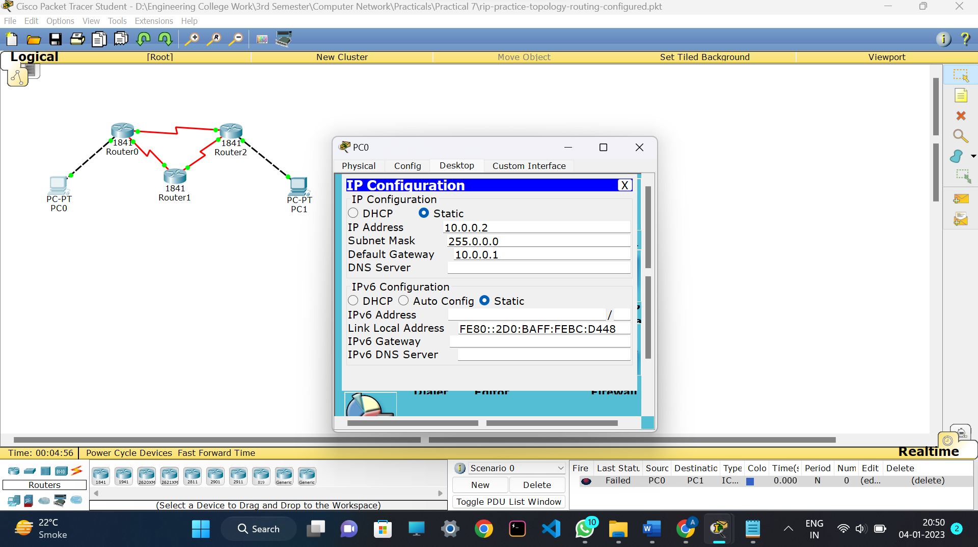

**PC1:**

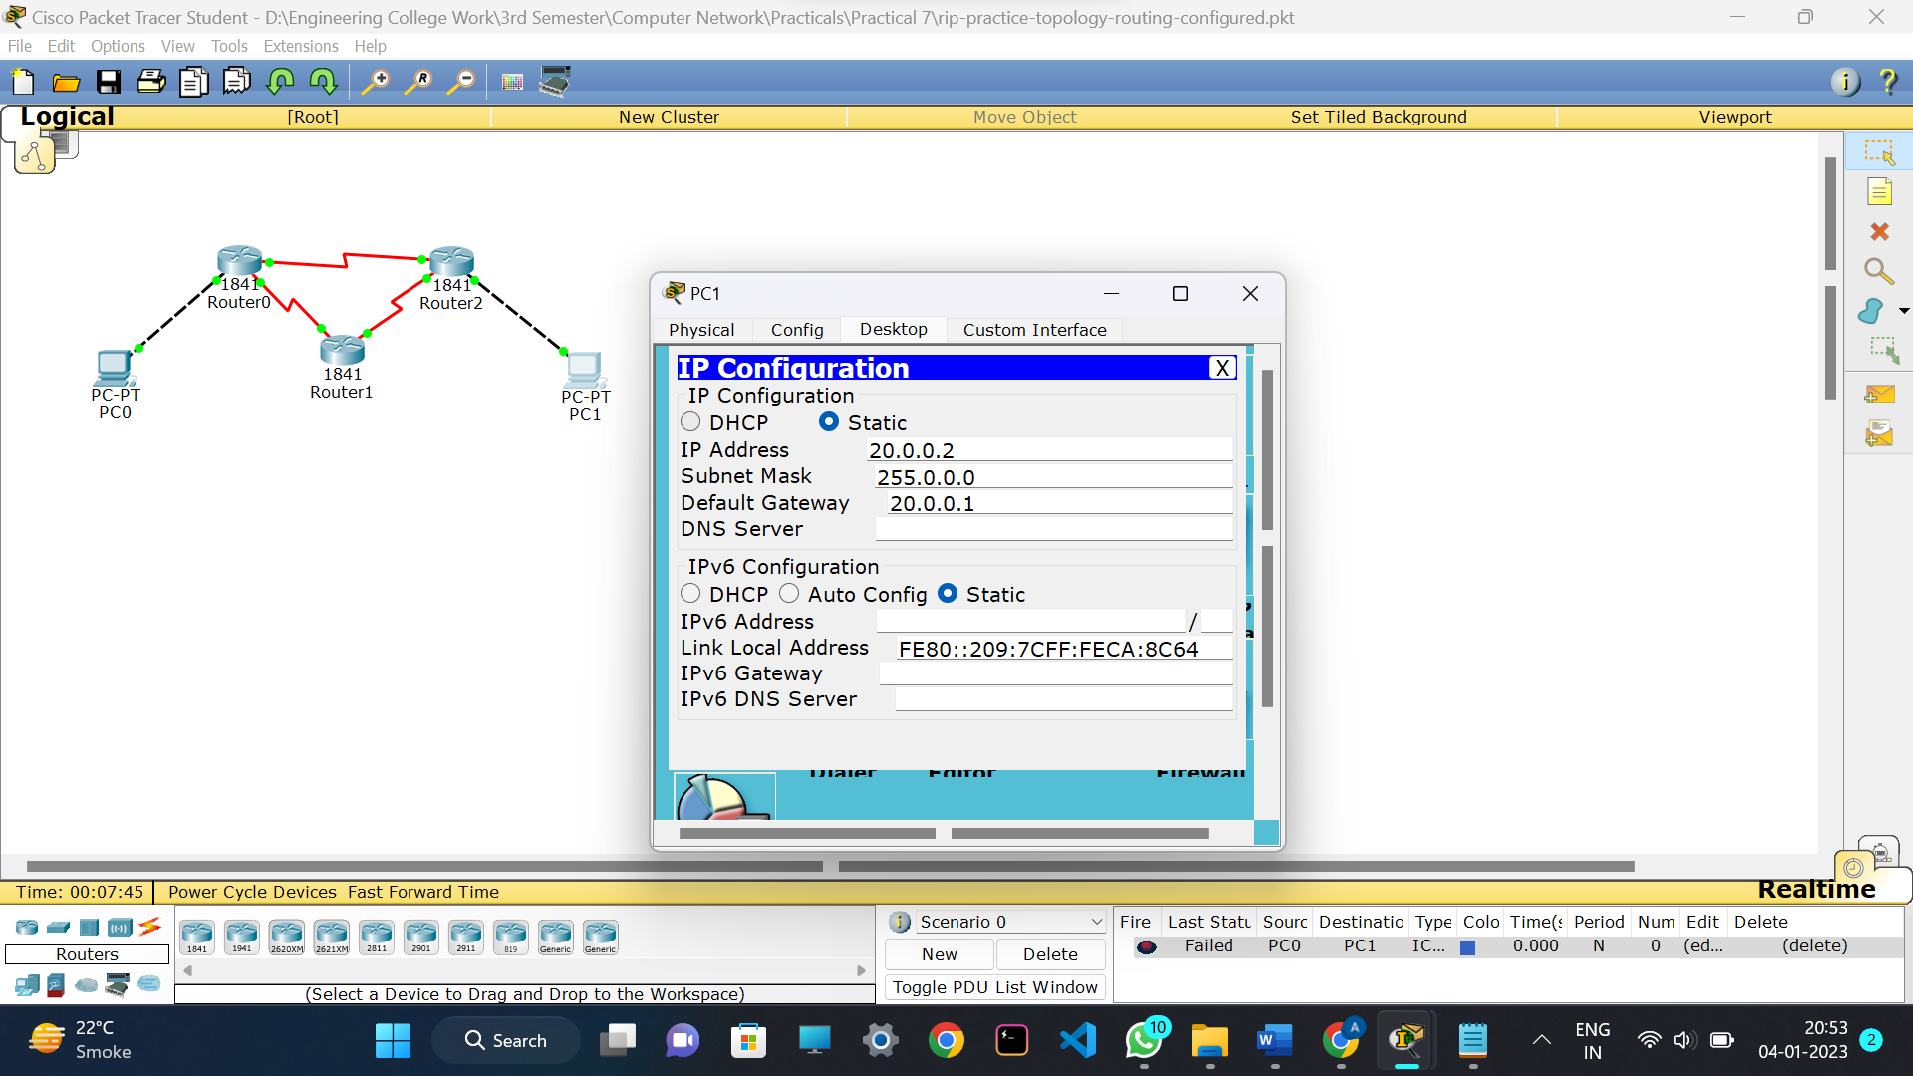

**Routers Hardware(1,2,3):**

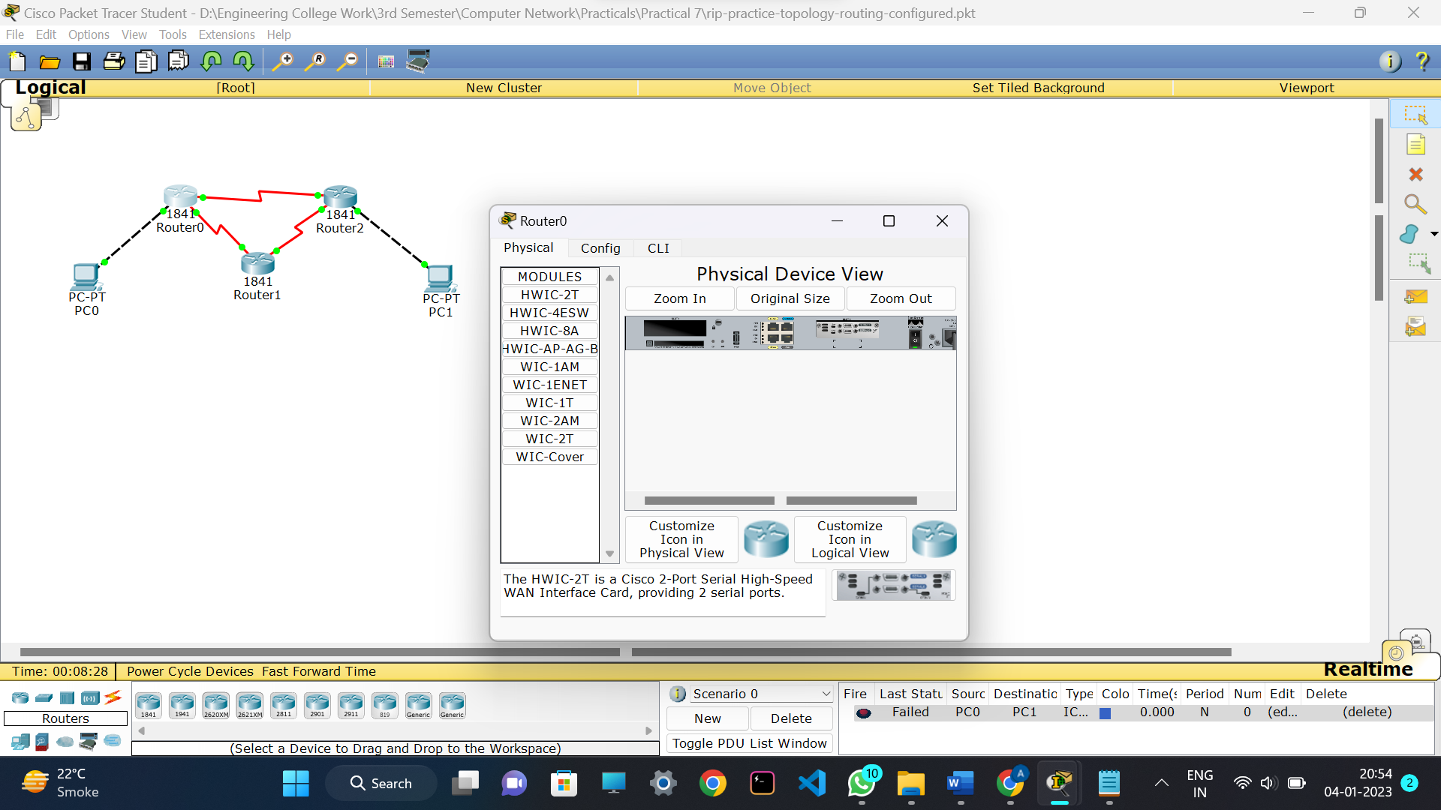

**Output:**

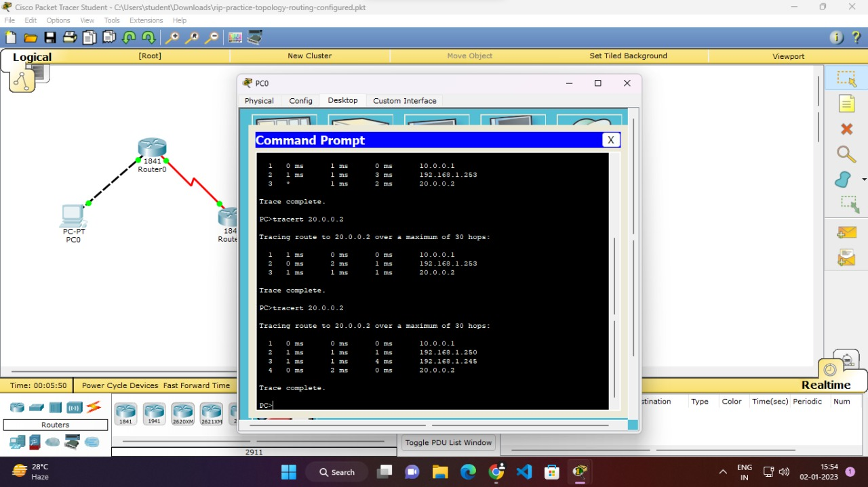

**Conclusion:**

In this practical, we learnt about configure network using distance vector routing protocol in cisco packet tracer and successfully implemented it in our practical.